**Task: Setup minikube at your local and explore creating namespaces**

**Installing kubernetes:**

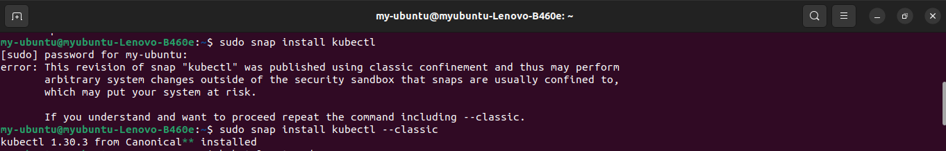

**Installed minikube and starting it:**

**Used Commands:**

~ curl -LO https://storage.googleapis.com/minikube/releases/latest/minikube-linux-amd64

~ sudo install minikube-linux-amd64 /usr/local/bin/minikube && rm minikube-linux-amd64

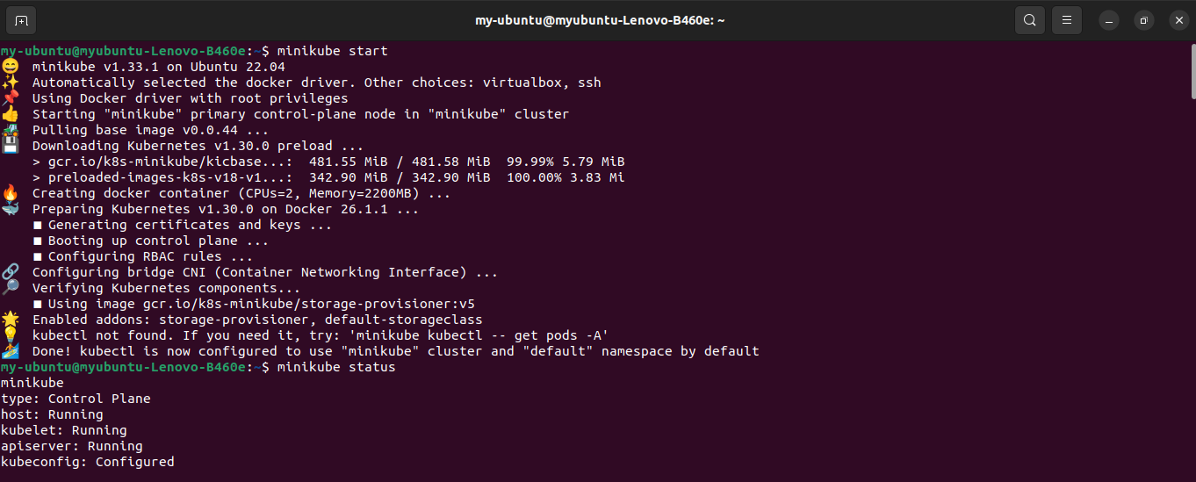

**Copying installed minikube directories to local Machine:**

**Starting minikube from local**

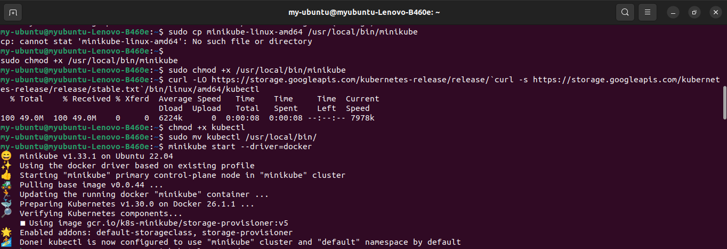

**Verifying whether the application installed is running using** kubectl get nodes **command:**

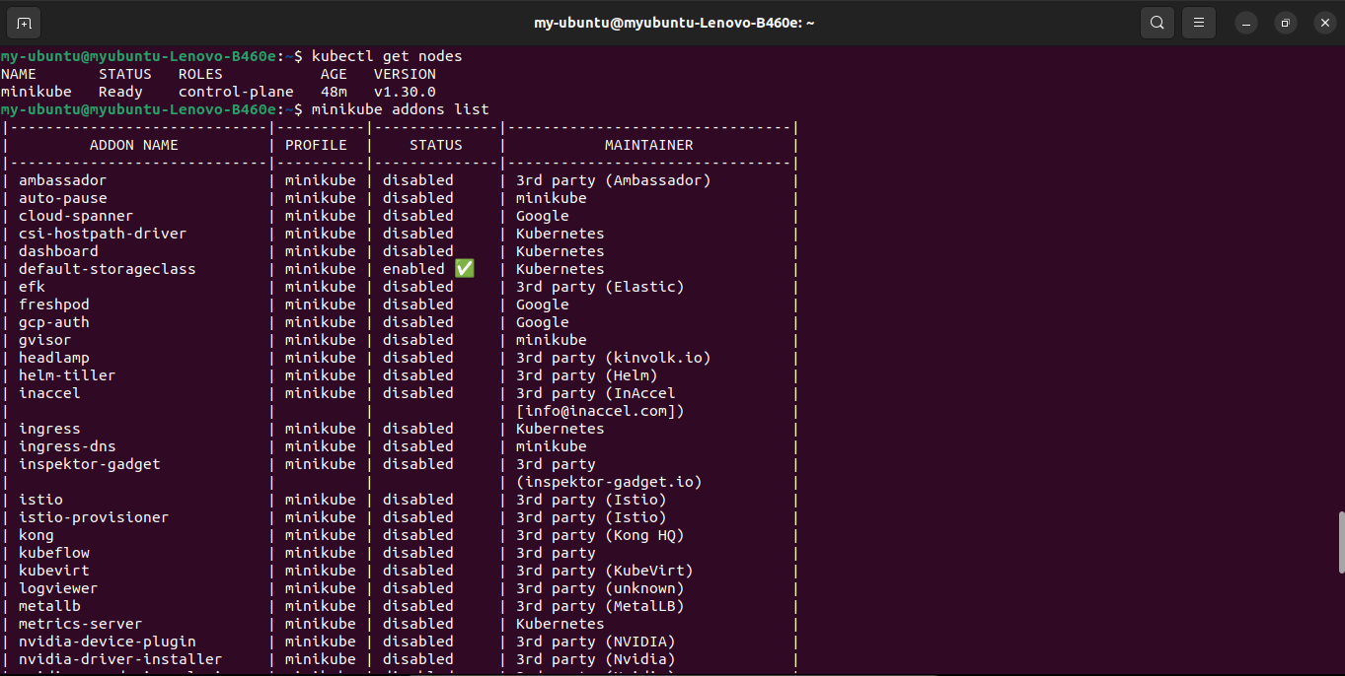

**Enabling Dashboard addon in minikube:**

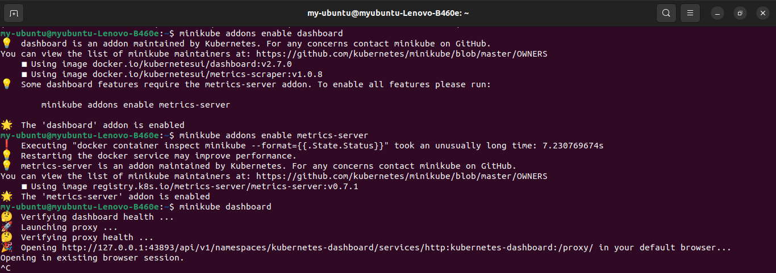

**Dashoard is running:**

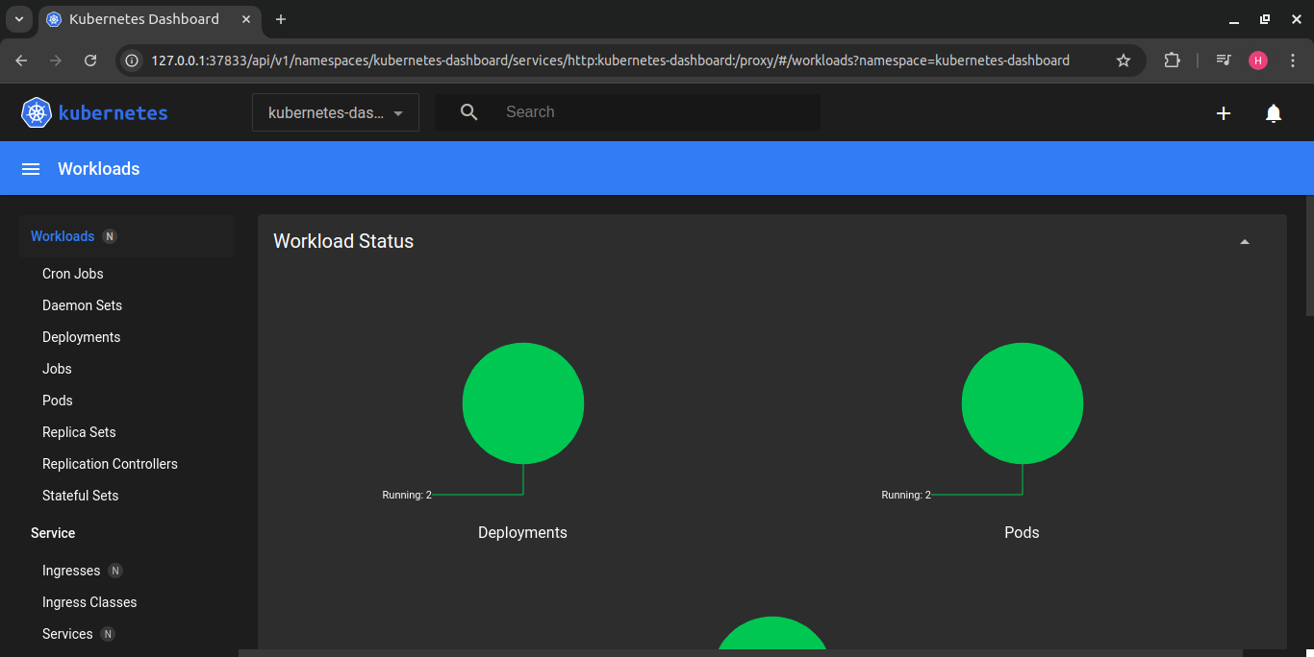

**Creating namespace:**

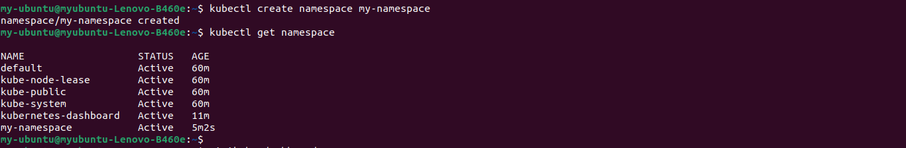

**Created namespace is available in the Dashboard:**

